AC_PRS_1- Update personal information (Done by: Anisa Domi)
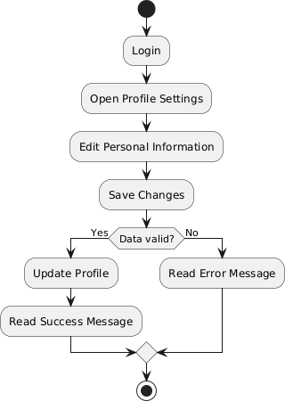

AC_PRS_2 - Search properties (Done by: Anisa Domi)
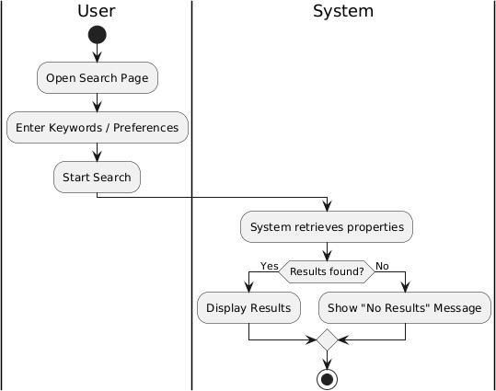

AC_PRS_3 - Filter properties (Done by: Anisa Domi)

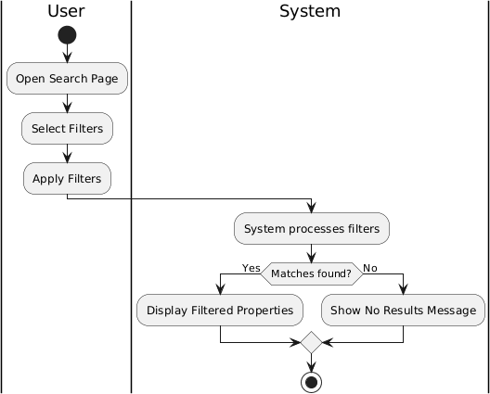

AC_PRS_4 - View property details and booking history. (Done by: Anisa Domi)

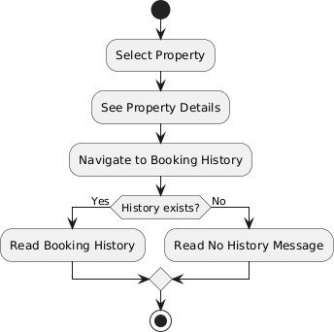

AC_PRS_5 - Send rental requests and message to property owners. (Done by: Anisa Domi)

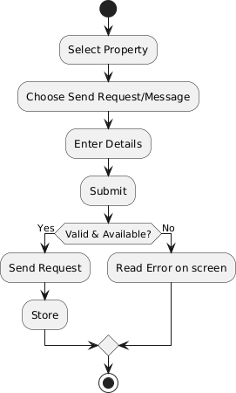

AC_PRS_6 - Cancel rental request (Done by: Anisa Domi)

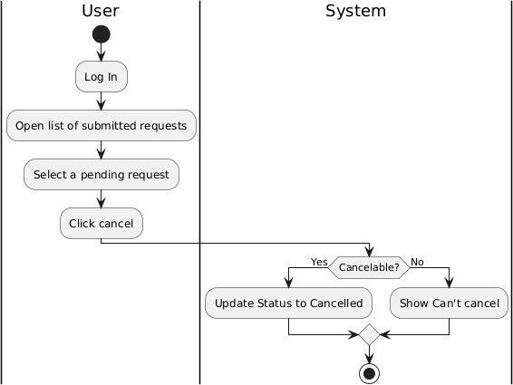

AC_PRS_7 - Receive messages from property owners. (Done by: Haidi Toto)

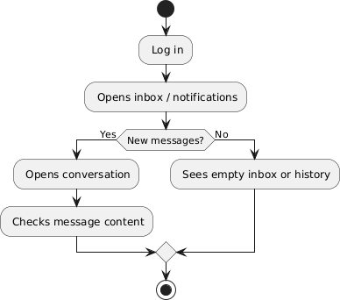

AC_PRS_8 – Submit rental payments. (Done by: Haidi Toto)
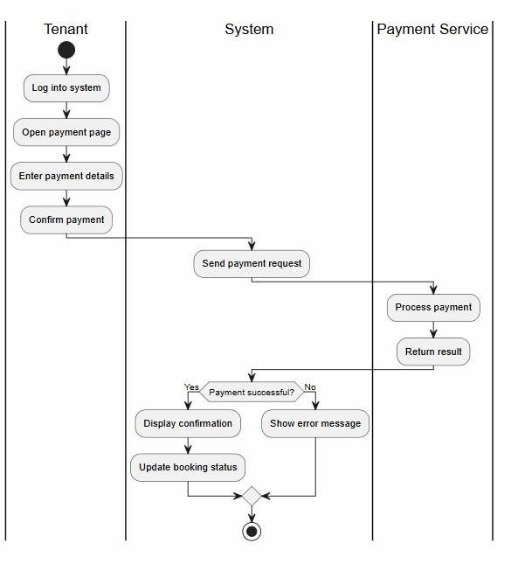

AC_PRS_9 - Save favourite properties for later viewing. (Done by: Haidi Toto)

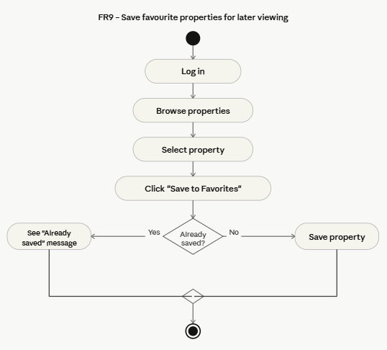

AC_PRS_10 – Review and Rate property (Done by: Haidi Toto)

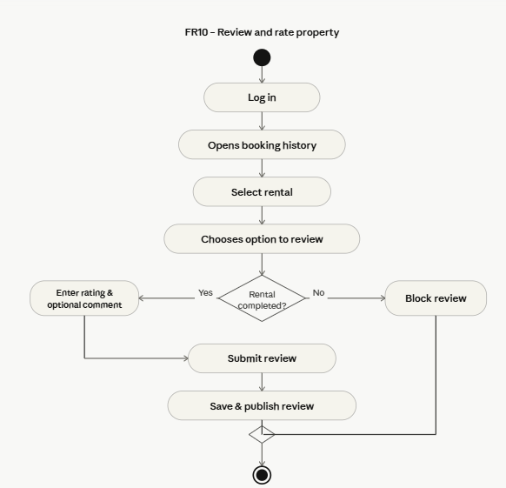

AC_PRS_11 - Update Profile Information and availability of rental properties (Done by: Haidi Toto)
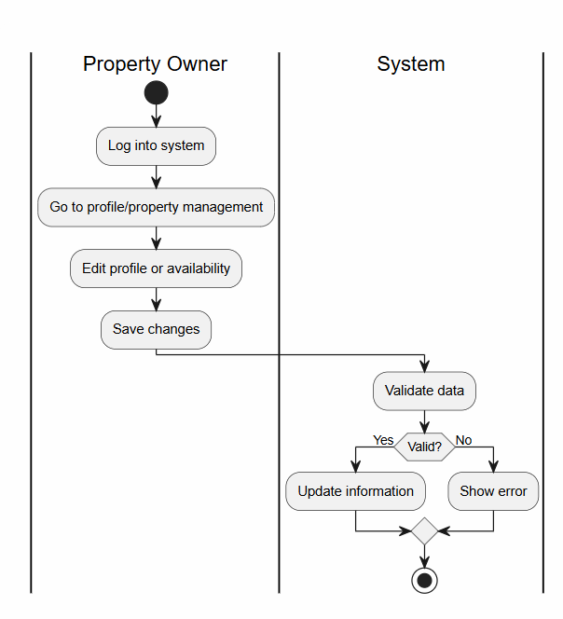

AC_PRS_12 - Add Property Listing (Done by: Haidi Toto)
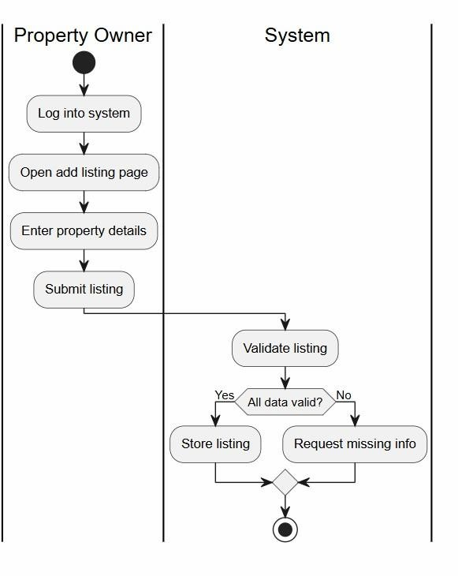

AC_PRS_13 - Upload Property Images (Done by: Ledio Tafciu)
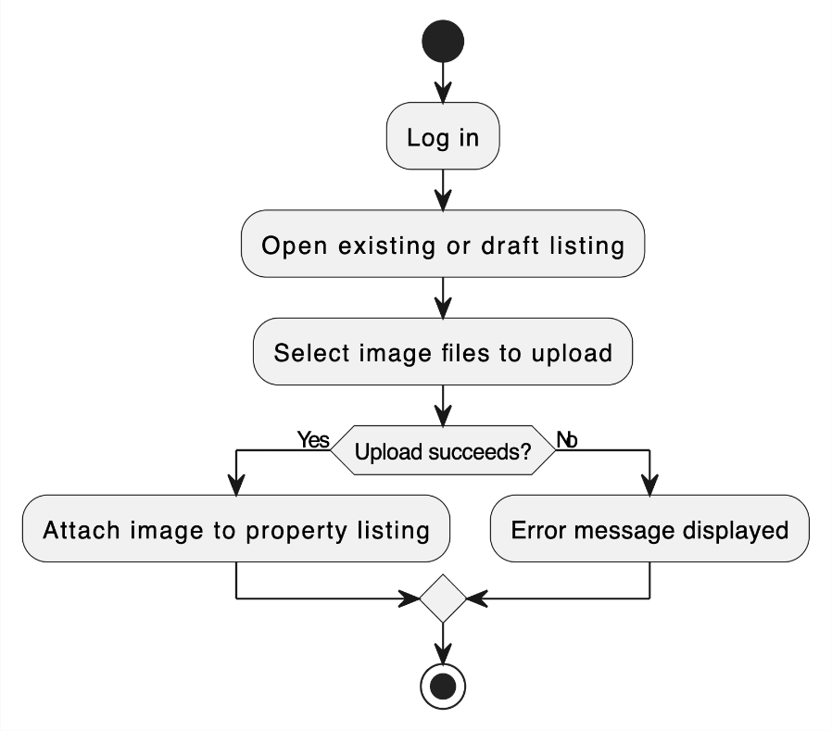

AC_PRS_14 - Edit Property Listing (Done by: Ledio Tafciu)

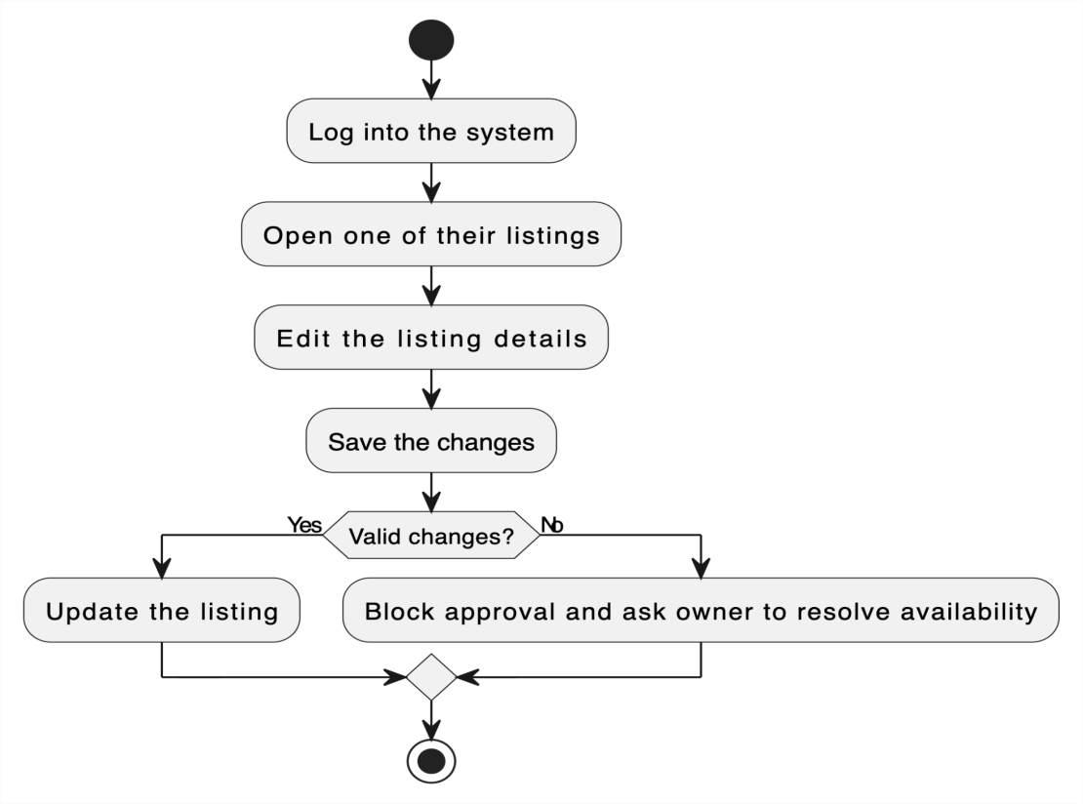

AC_PRS_15 - Delete Property Listing (Done by: Ledio Tafciu)
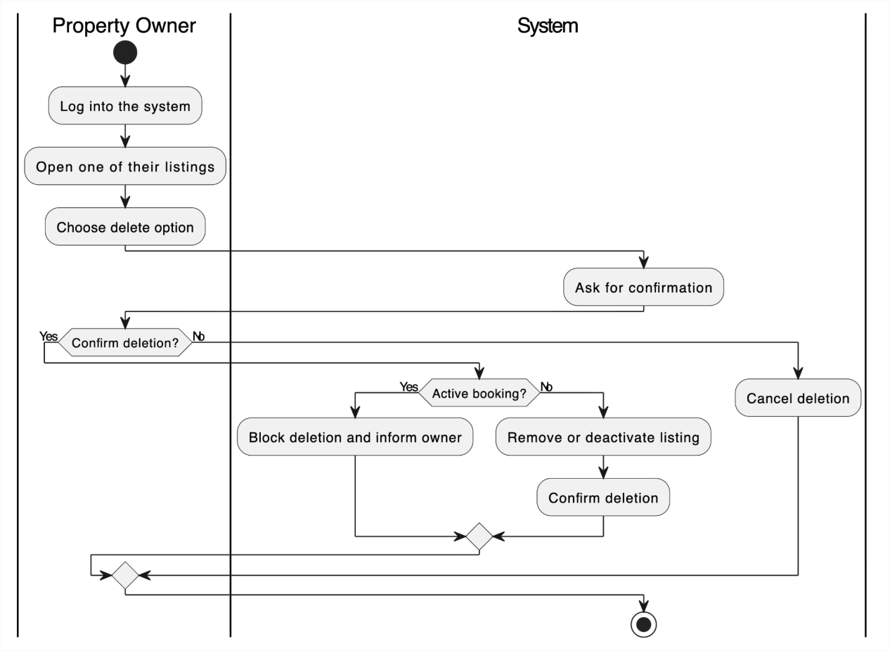

AC_PRS_16 - View Rental Requests (Done by: Ledio Tafciu)
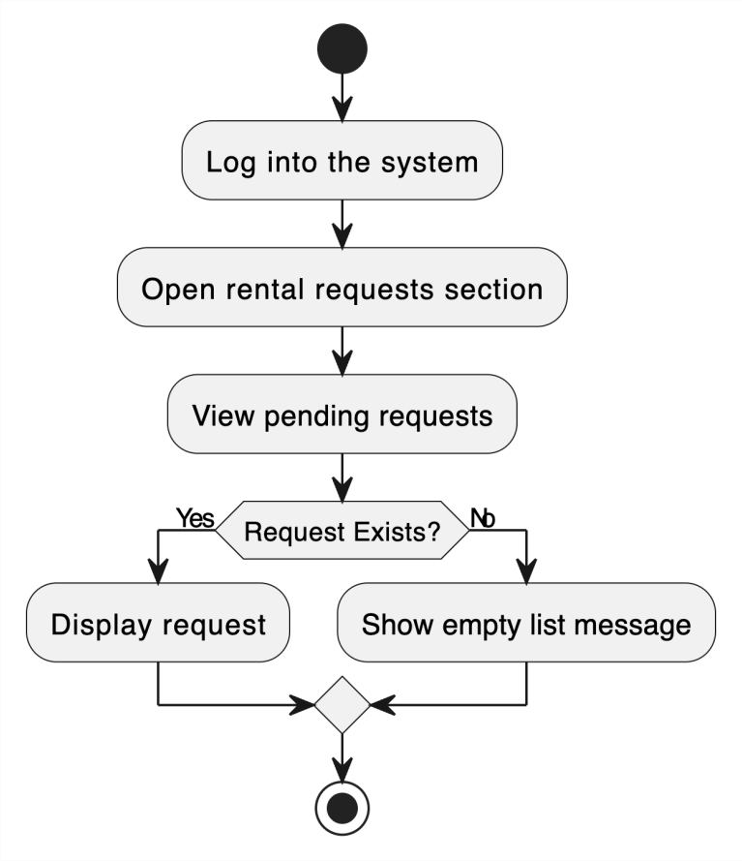

AC_PRS_17 - Accept or Reject Rental Request (Done by: Ledio Tafciu)
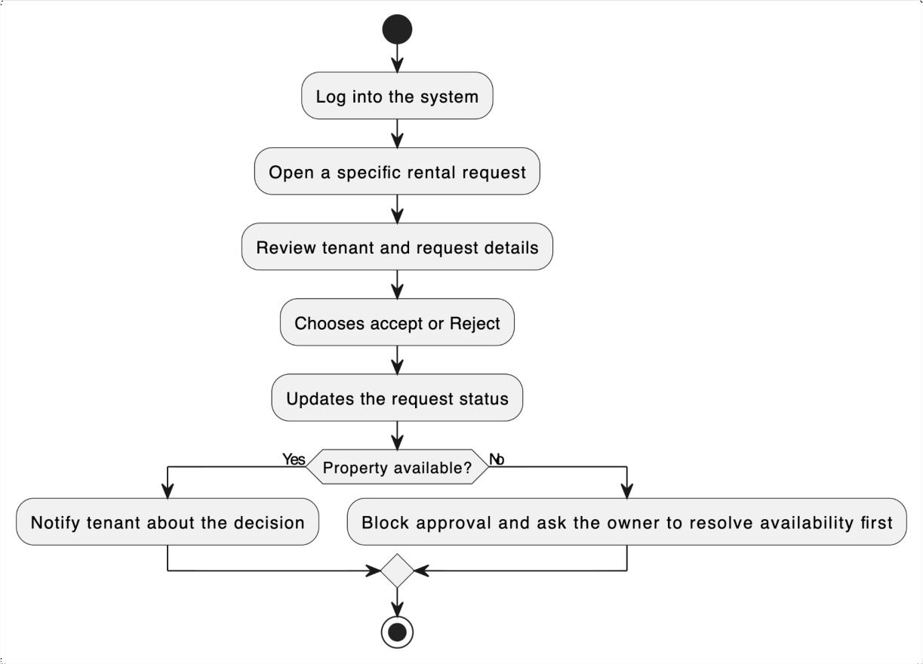

AC_PRS_18 - Send Message to Tenant (Done by: Ledio Tafciu)
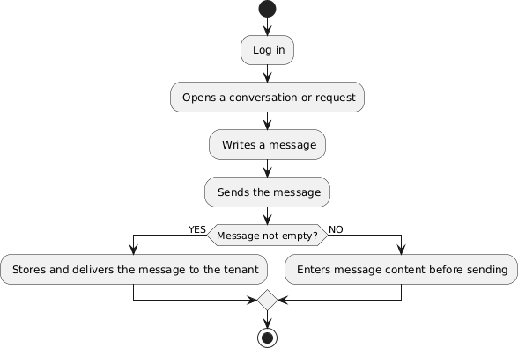

AC_PRS_19 - View Booking History (Done by: Desard Lybeshari)

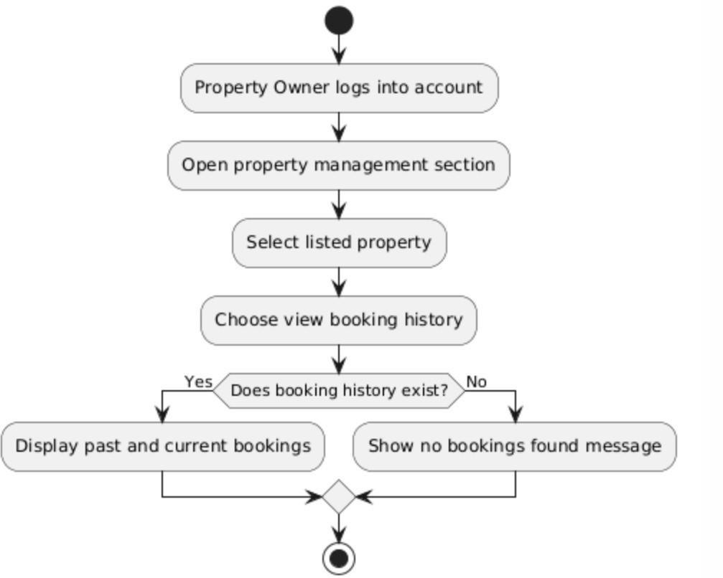

AC_PRS_20 - Mark Property as Unavailable or Rented (Done by: Desard Lybeshari)

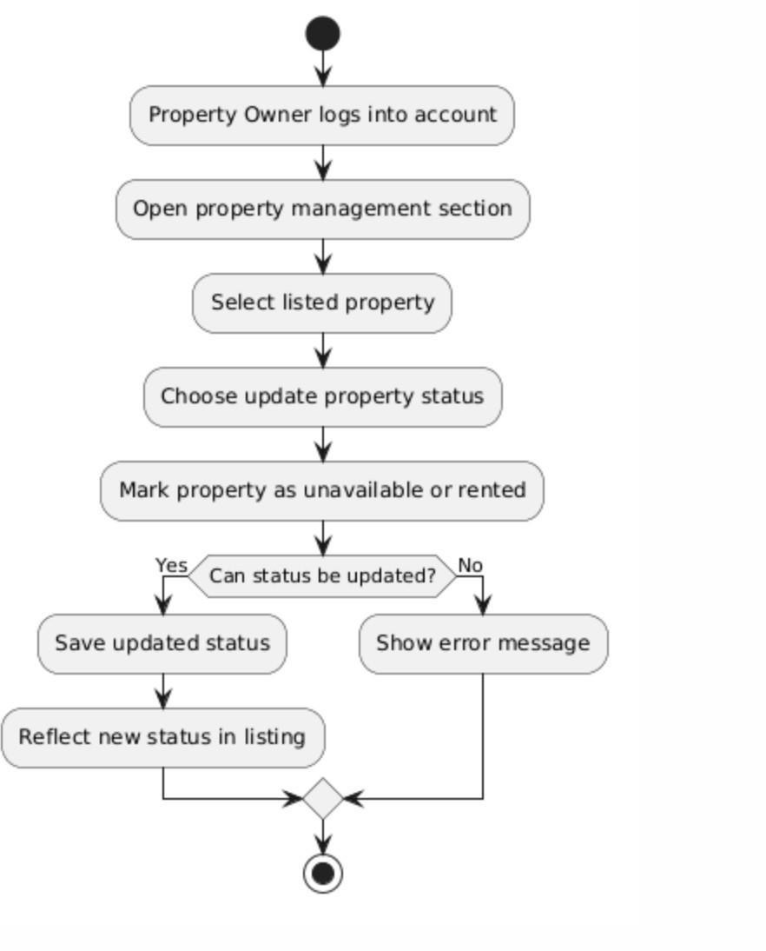

AC_PRS_21 - Edit User Accounts (Done by: Desard Lybeshari)
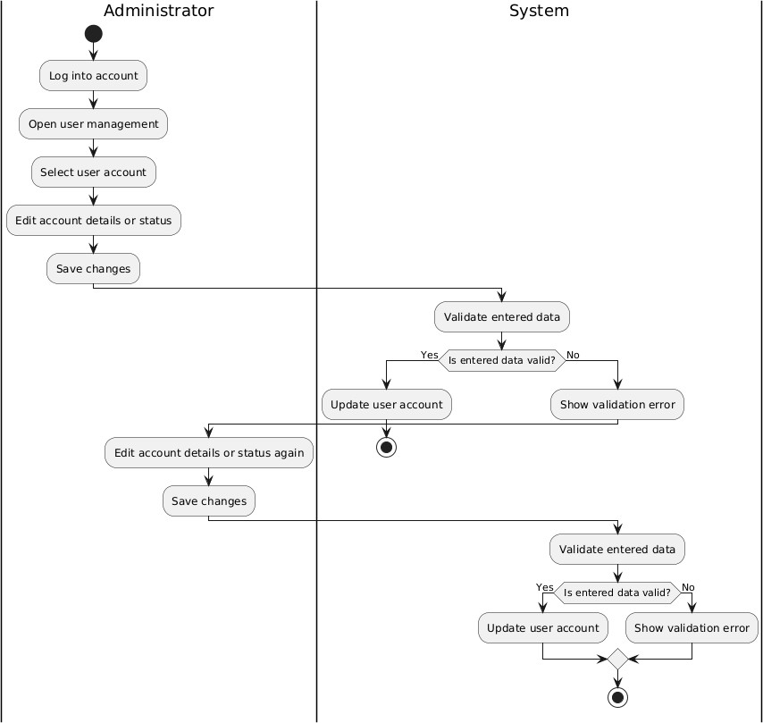
AC_PRS_22 - Delete User Accounts (Done by: Desard Lybeshari)

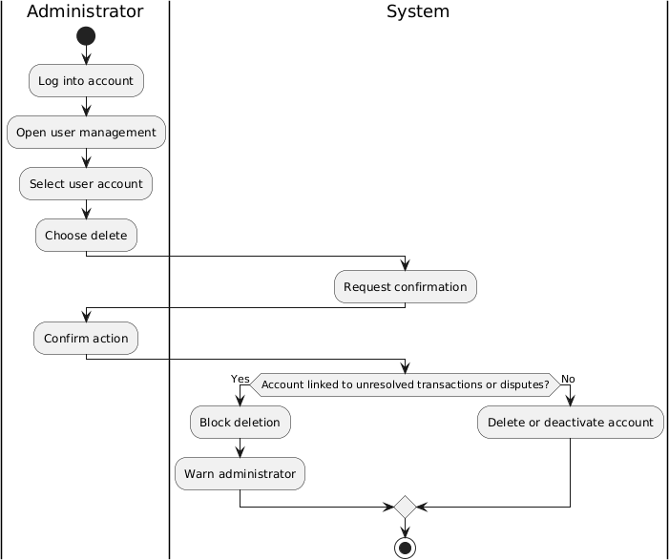

AC_PRS_23 - Monitor Rental Transactions (Done by: Desard Lybeshari)

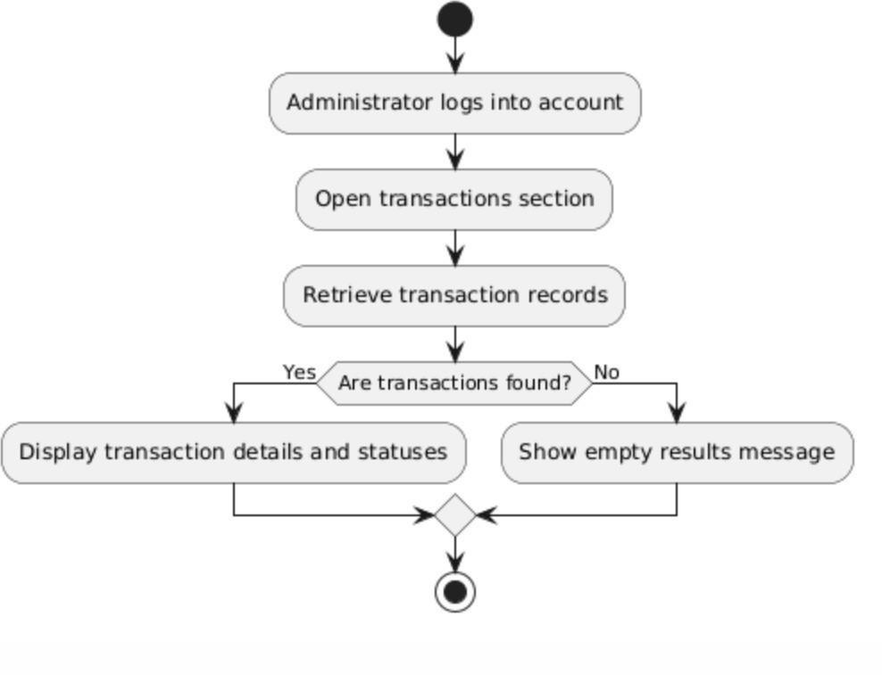

AC_PRS_24 - View System Reports and Property Listings (Done by: Desard Lybeshari)

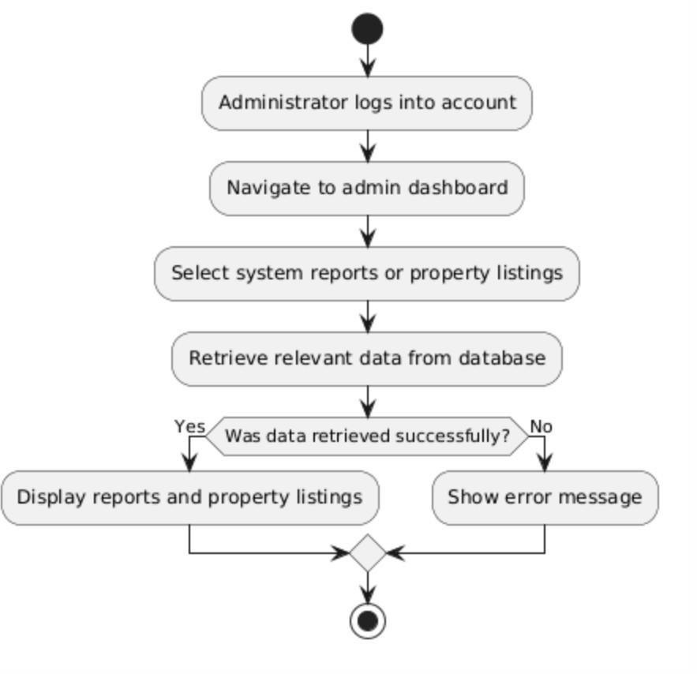

AC_PRS_25 - Remove Inappropriate Listings (Done by: Matias Bali)

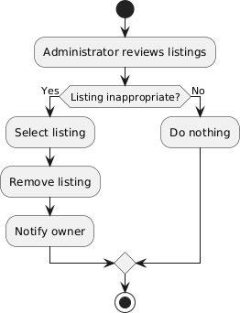

AC_PRS_26 - Manage Disputes and System Settings (Done by: Matias Bali)
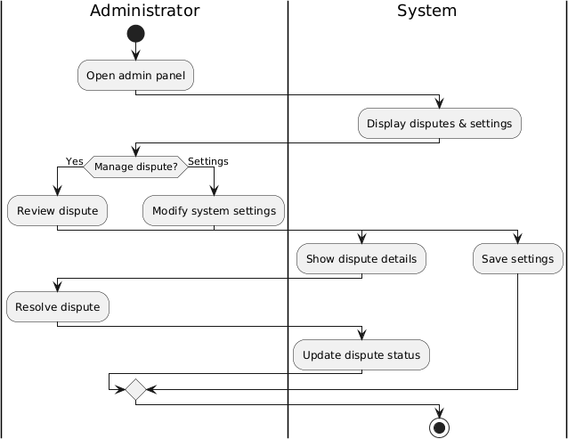

AC_PRS_27 - Restore User Accounts (Done by: Matias Bali)
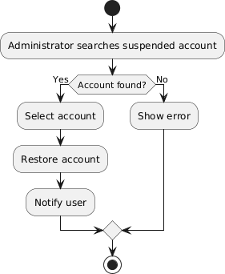

AC_PRS_28 - Suspend User Accounts (Done by: Matias Bali)
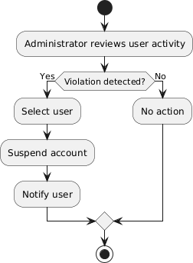

AC_PRS_29 - Verify and Approve property listings (Done by: Matias Bali)
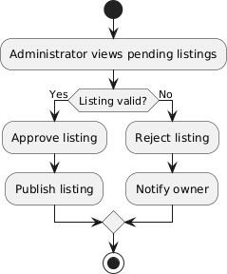

AC_PRS_30 - Monitor Rental Requests (Done by: Matias Bali)

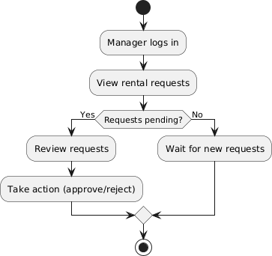

AC_PRS_31 - Generate Management Reports (Done by: Ornelt Lemellari)

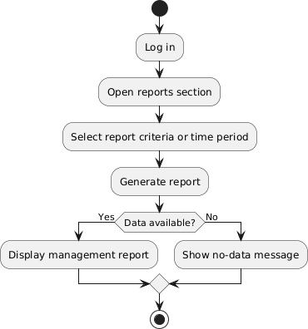

AC_PRS_32 - Approve Large Discounts and Promotions (Done by: Ornelt Lemellari)

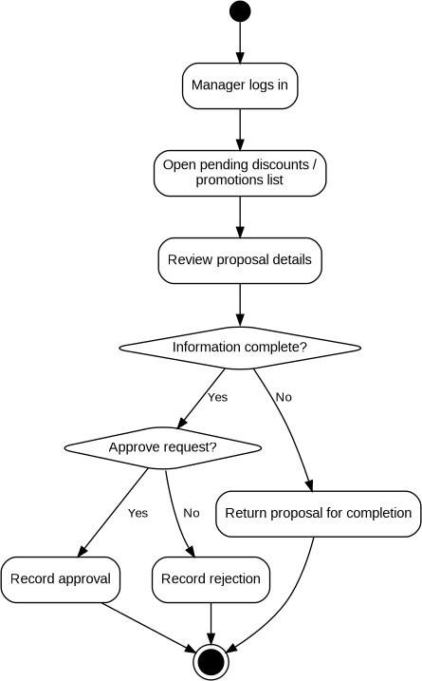

AC_PRS_33 - Review Complaints and Forward Unresolved Issues (Done by: Ornelt Lemellari)

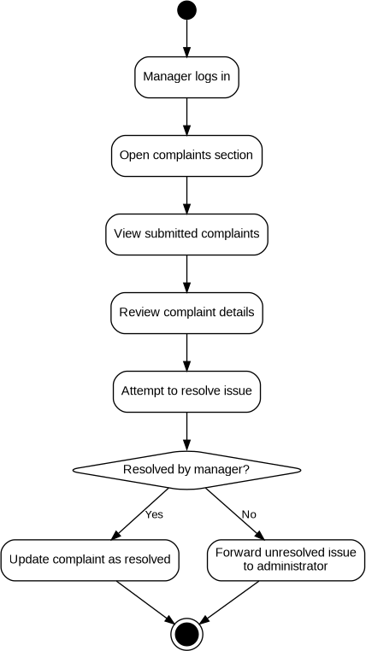

AC_PRS_34 - View Transaction History (Done by: Ornelt Lemellari)

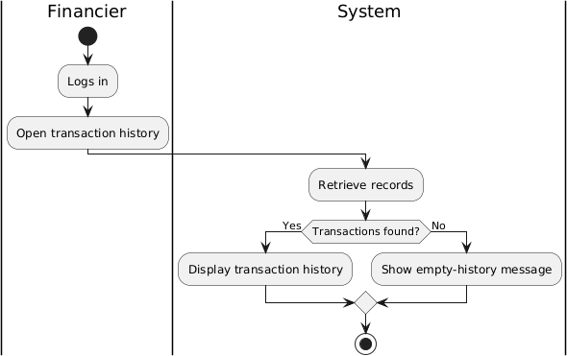

AC_PRS_35 - Monitor Payment Process and Security (Done by: Ornelt Lemellari)
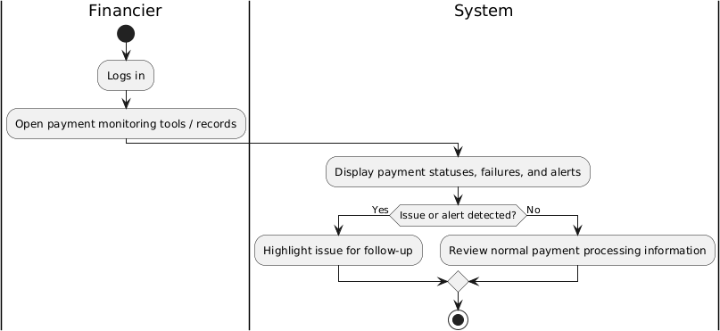

AC_PRS_36 - Communicate Payment Issues with Tenants and Owners (Done by: Ornelt Lemellari)

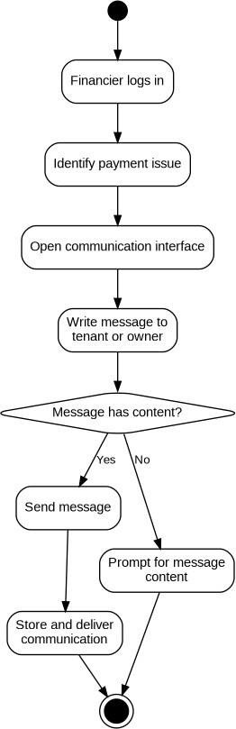

AC_PRS_37 - Approve Refunds for cancelled Rental Transactions (Done by: Kevin Muho)

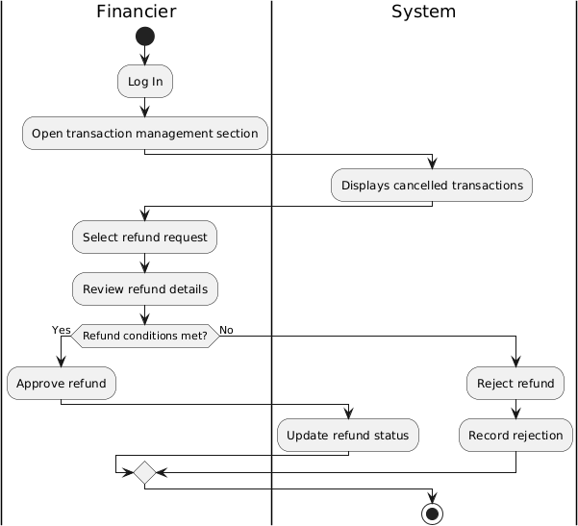

AC_PRS_38 - Manage Complaints (Done by: Kevin Muho)

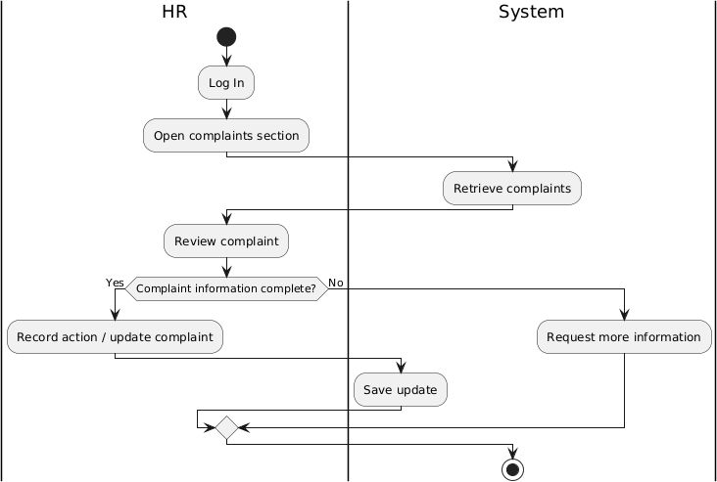
AC_PRS_39 - Send Notifications and Reminders (Done by: Kevin Muho)

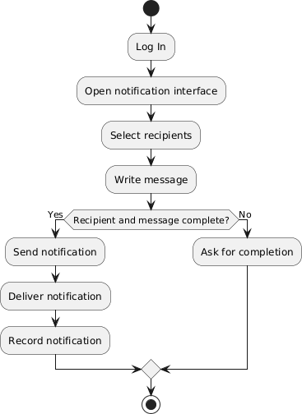

AC_PRS_40 - Maintain Records of User Issues and Resolutions (Done by: Kevin Muho)

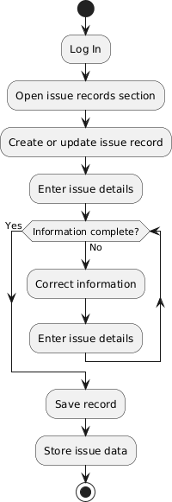

AC_PRS_41 - Register Account (Done by: Kevin Muho)

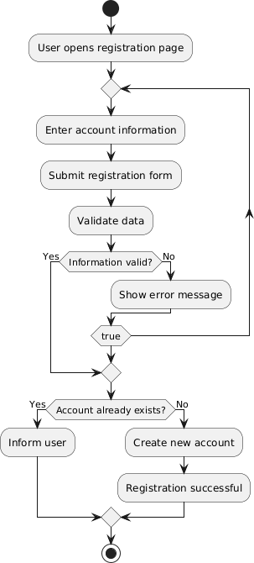

AC_PRS_42 - Log In (Done by: Kevin Muho)

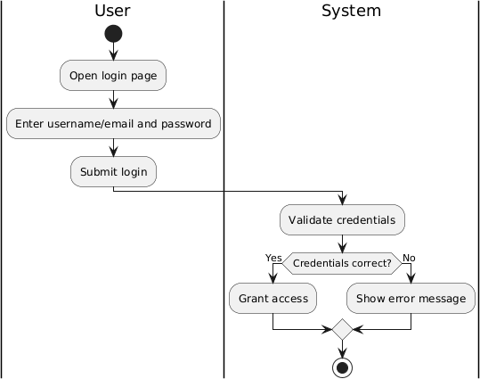

AC_PRS_43 – Log Out (Done by: Kevin Muho)

